R53 New Features

This release includes the following additions and modifications to functionality:

Contents
R53 New Features 1
1.1 Fire Patrol 2
1.1.1 Sum Benefit Acres 2
1.2 Levy Certification 3
1.2.1 Linked Levies 3
1.2.2 Timber assessed Value (TAV) 4
1.3 REET 5
1.3.1 Multiple Location Codes 5
1.3.2 Deleted Property 7

Fire Patrol

Sum Benefit Acres
(240639)
The Sum Fire Patrol Benefit Acres by Owner Dialog box only shows the agency Fire Patrol. There are no other FP type special assessments being brought into this process, just the one. In this case, we are looking at the clients training environment where they have set up 2 new FP type assessments which are FFPA and LOC special assessments related to instructions from the DNR.

DNR Wildfire Assessments
Annually, DNR will send rate letters to the Assessor and Treasurer with the assessment rates for both FFPA and LCFFSA for the following year. These are two separate assessments and it is DNR’s recommendation that they be separated on property tax statements.

Process dialog was changed to allow selection of the (FP) type assessment on which to perform the Update. Each assessment will have to be run for itself, there is not an ALL option.

- Assessor role > Activities > Special Assessment > Sum Fire Patrol Benefit Acres by Owner
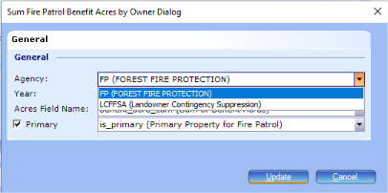

Levy Certification

Linked Levies
(235277)
Our Levy Calculation Summary Report is not matching the Tax District Summary Panel on four of the levies. In the past the report was incorrectly showing the State Levy 2 as an administrative refund. State Levy 2 was removed from the administrative refund area and now does not show up on the report at all (we have it linked). The combined rate is not displayed on the report. My understanding is that the focus group requested that these linked levies not show up as administrative refunds as this is misleading for an earmarked levy. Having the details of the linked levies simply disappear from the report wasn’t the result we had hoped for.

Added rows for Linked Levies to each major section (THERE IS NO BREAKOUT FOR MULTIPLE LINKED LEVIES, TOTAL RATE IS DISPLAYED)
- Activities -> Levy -> Levy Certification -> open latest Run ID -> click on Tax District Summary. Then click the Print button the get the Levy Calculation Summary Report
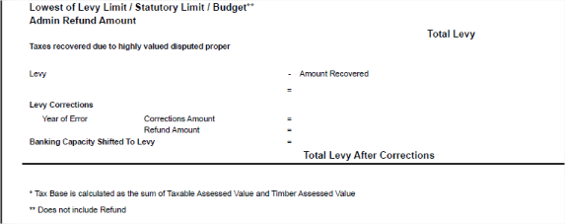
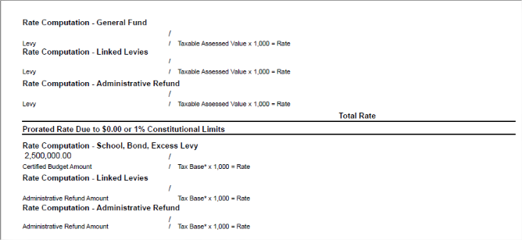
_{Levy}

Timber assessed Value (TAV)
(235038)
If the Tax District has TAV checked, it should also look at what is selected in the drop down which contains (Full, Greater of Half or Roll or Not Used) and if Not Used is selected, do not include it in the reports.

In PACS, the Taxable Value used to include the timber_assessed_full and timber_assessed_half values with no regard to settings. Now those components are only included if the timber_assessed_enabled is on (the box is checked under the tax district levy) at which point the timber_assessed_cd dictates what value is pulled in (FULL for timber_assessed_full, HALF/ROLL for timber_assessed_half and anything else pulls in no timber value).
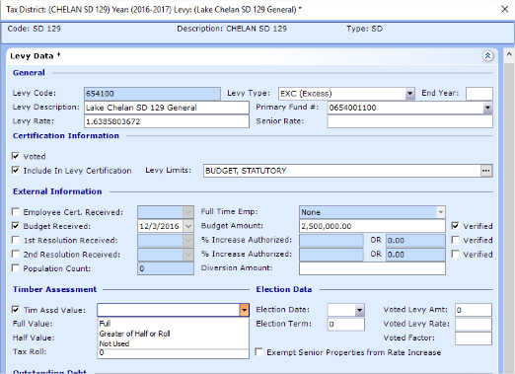
- This change has been implemented in the following dialog areas:
  - Annexed Value Levy Amount
  - Calculate Highest Lawful Levy
  - Calculate Highest Lawful Levy Rate
  - Lid Lift Levy
  - Levy Certification recalculate
- Reports affected include:
  - Certification of Levies (Reports > Levy > Levy Rates Report)
  - Levy Rates Report (Reports > Levy > Levy Rates Report)
  - Tax District Summary Report
    - The TAXABLE Value in PACS should show the taxable value and the proper levy rate.
      - However, on the Tax District Summary Report some areas are labeled TAX BASE (which is Taxable Assessed Value + Timber Assessed Value) and others are labeled only as the Taxable Assessed Value (therefore NOT including the Timber Assessed Value).
      - Some locations on the report may not match PACS because a different denominator is used.

REET

Multiple Location Codes
(224359)
There was a legislative change made to give users the ability to process multiple location codes on a REET. Before this there was an error message that would populate when different location codes exist on a REET. Now there is no error even if the user does not select.

Warn user for non-multi location and taxable REETS when location codes do not match. Select ‘Multiple Location’ indicator on REET when user selects to move forward with different location codes.

- File > New > REET > select taxable REET, pick properties in different tax areas and add them to the REET
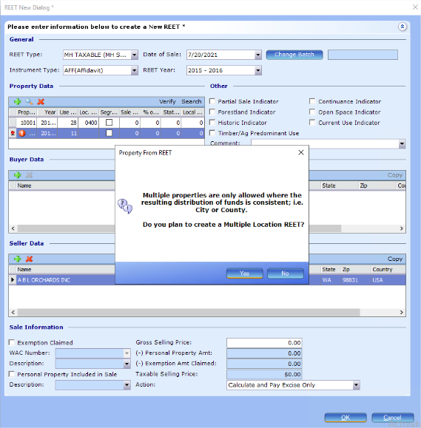
  - No – clears the property from the list

  - Yes –
    - adds the property and selects the ‘Multiple Locations’ check box on the record
    - the user MUST complete the multiple locations data to report correctly by entering
      - Property Data grid: Sale Price, % of Sale, State & Local REET amounts
      - Combined Sale Price and any deductions
      - County REET grid: County Name, State & Local REET
1
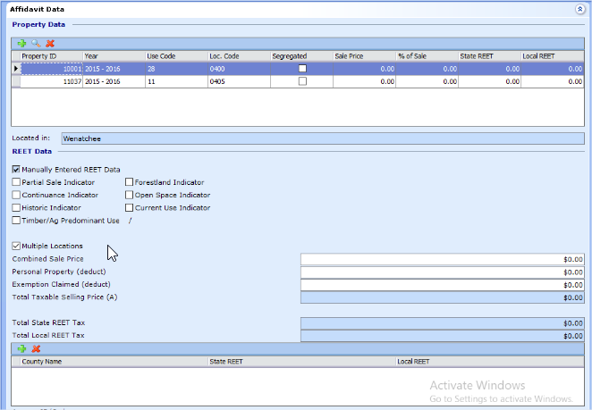
2
3
- Other scenarios affected:
  - REET Type change
    - REET type change on a new REET - When REET type changed to taxable warning message displayed
    - REET type change on existing REET -
      - Changing Taxable type to other Taxable type displays warning message
      - Changing Taxable type to Non-Taxable type does not display warning message
      - Changing Non-Taxable type to Taxable type displays existing Taxable warning message. Properties are not cleared because the multiple locations indicator is still selected. Users should review property associations as indicated in the warning.
  - Existing REET with Taxable REET type
    - When user selects multiple properties with different location code to an existing REET, multiple location validation message displayed

Deleted Property
(224359)
As I worked through a test REET transaction on a deleted account, no flag (like the current use one) pops up during processing to prevent an excise transaction from being completed on a deleted account. This is a summarized explanation of what we have encountered as an example:
We have land parcels intended for development as condo projects that are in line to be segregated, but frequently the condos are built and sold before the segregation and accompanying supplement are completed by the Assessor's office, or perhaps by our Planning Department. OR the segregation is completed in a future year; I understand that Ashley put forward a development request to allow us to attach REET affidavits to accounts in a future year layer when we are working in the current one.
In the meantime, the parcel number specified on the sale paperwork and excise affidavit by the escrow agency is currently to use the deleted account (which was the original land parcel).

Add a popup for warning that the account is a deleted one. The notification does not prevent the user from retaining that Property as a selection.

- There are 3 locations properties can be added to a REET:
  - 1) Creating a new REET and manually entering the Prop ID in the grid
  - 2) Creating a new REET and using the Search Wizard
  - 3) Viewing an existing REET and using the Search Wizard
- The warning message will list for any and all deleted Properties being added through that transaction.
