Special Assessment Changes – October 2020
Added functionality to include Proposed Rates for Special Assessments. A new way of importing special assessment hearing information, rate, proposed rate at the iteration level from a xls file.
To import the Hearing Information and the Iteration Rate and Proposed Rate , the existing “Special Assessment” component under Home > Import will launch the existing Special Assessment Import and these two new Special Assessment imports.

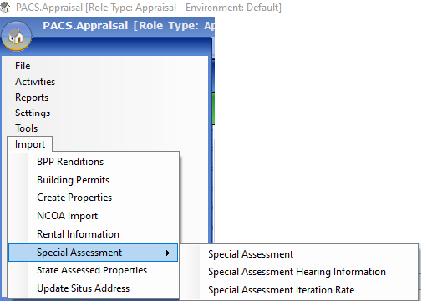

Following options are available:

- Special Assessment
  - The existing Special Assessment Import will be moved to this location (Home > Import > Special Assessment).

- Special Assessment Hearing Information
  - This new option will be added to Home > Import > Special Assessment.
  - “Special Assessment Hearing Information Import” dialog will open. This dialog will allow the user to import all hearing information related to the Special Assessment.
Menu Option: PACS Menu Import Special Assessment Special Assessment Hearing Information

Only users that have the Execute privilege on the “Special Assessment Hearing Information” security feature can perform this import.
Security Right: Import Special Assessment Hearing Information (Execute)

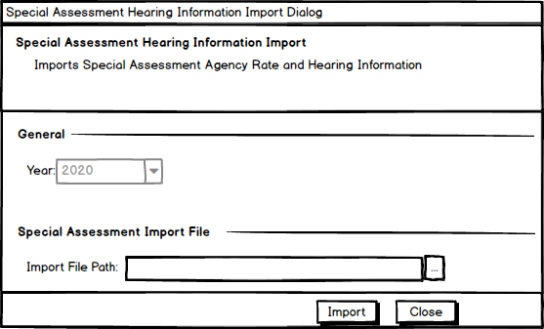
The dialog will contain the following fields:
- Year – This field will always display the current tax year
  - It will be a read only field.

- Import File Path – A file chooser allowing the user to select a file to import using the … button next to it.
  - This is a required field.
  - The file must be located in a valid network path (the path must begin with “\\”).
  - The file must be an Excel workbook (XLSX)
- Import
  - The ‘…’ button will be used to import the Special Assessment Hearing Information data.
  - When the user clicks the ‘…’ button next to the “Import File Path”, the following validations will be performed and any validation error messages will be displayed to the user.
- The year is the current tax year.
Error message - Import can only be processed for the current tax year.
- The Special Assessment agency in the import file must be a valid special assessment agency in the system.
Error message - The special assessment (X) does not exist.
- The import file path is not empty and the file is an xlsx valid file.

  - If all options are valid, the application will import the hearing information to:
    - The hearing information displayed on the Special Assessment Details
    - If there is only one Iteration and only one rate for the assessment, the Rate and Proposed Rate being imported will be copied over to the Rate and Proposed Rate for that single iteration that is displayed on the Edit Fee screen.
    - If there are multiple iterations or multiple rates, the rate will not be copied over.

This just gives the user the ability to set the Rate used in the calculation from the Imported rate when the calculation is just a simple iteration.

The xls file data will map to the database fields as follows:
Column Name | Table Field Name | Notes
Agency Code | agency_cd | FK value to [special_assessment_agency]. assessment_cd.  Required.
Rate | Rate | Needs to be numeric, null or empty
Proposed Rate | prop_rate | Needs to be numeric, null or empty
Hearing Location | hearing_location
Hearing Date | hearing_date | Needs to be a date
Hearing Time | hearing_time | Needs to be a time
Hearing Phone Number | hearing_phone_num
Total Revenues Collected | trim_total_assessment_revenues

Any invalid data in the excel file will cause the Import to fail and the reason for the failure will be displayed in the PACS Inbox.
- Special Assessment Iteration Rate
  - This new option will be added to Home > Import > Special Assessment.
  - “Special Assessment Iteration Rate Import” dialog will open. This dialog will allow the user to import rate and proposed rate within specified ranges for an iteration.
The user can import Special Assessment Iteration Rate and the new Proposed Rate using this new dialog.
Menu Option: PACS Menu Import Special Assessment Special Assessment Iteration Rate

Only users that have the Execute privilege on the “Special Assessment Iteration Rate Import” security feature can perform this import
Security Right: Import Special Assessment Iteration Rate Import (Execute)

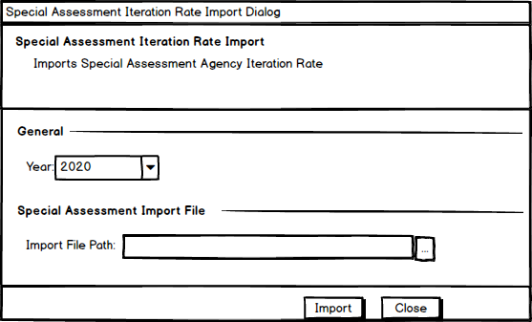

The dialog will contain the following fields:
- Year – This field will allow the user to select the year for the import.
  - Only uncertified years will be available for selection.
  - The default shall be the current assessment year
  - The user shall be allowed to select the Future Year Layer.
  - This will be a required field.
- Import File Path – A file chooser allowing the user to select a file to import using the … button next to it.
  - This will be a required field.
  - The file must be located in a valid network path (the path must begin with “\\”).
  - The file must be an Excel workbook (XLSX) and must use the format
- Import
  - The … button will be used to import the Special Assessment Iteration Rate and Proposed Rate Information data.
  - When the user clicks the “…” button next to the “Import File Path”, the following validations will be performed, and any validation error messages will be displayed in the PACS Data Validation Summary dialog.
- Year is a required field and needs to be an uncertified year.
Error messages:
Year is a required field.
Year cannot be a certified year.
- The import file path is not empty and the file is a valid xlsx file.
  - If all options are valid, the application will clear old rate data and import the new rate data to the [special_assessment_iteration_rate] and the new special_assessment_agency_rate_schedule tables. If there is no default iteration , a default iteration will be added.
  - The file format of the import file must be an Excel workbook (XLSX) file each row represents a record with the following data elements corresponding to the fields in database as documented below:
Column Name | Table Field Name | Notes
'Agency Code' | agency_cd | FK value to [special_assessment_agency]. assessment_cd.  Required field.
'Code' | [special_assessment_agency_rate_schedule].code and [special_assessment_iteration_rate ].code | Any code that will be used to compare any field data in the calculation. For example, Fire Type
'Minimum Range Value' | [special_assessment_agency_rate_schedule].min_val | Needs to be numeric
'Maximum Range Value' | [special_assessment_agency_rate_schedule].max_val | Needs to be numeric
'Rate' | [special_assessment_iteration_rate].rate | Needs to be numeric
'Proposed Rate' | [special_assessment_iteration_rate].prop_rate | Needs to be numeric
Any invalid data in the excel file will cause the Import to fail and the reason for the failure will be displayed in the PACS Inbox
All special assessments in PACS are calculated exactly the same way – namely, Fee Amount = Units x Rate. The only thing that differs from one special assessment to the next, or even from one property to the next is how the number of units or the rate for a given property is chosen.

Simple HOA Fee Example
Considering a simple scenario where the Special Assessment is a $200/year HOA fee for houses in a neighborhood – it doesn’t matter how big or small the house is or any of that. In this case, the Units = 1 (for 1 house) and the Rate = $200. This can be set up in the Fee Builder quite easily.

Special Assessment Details Dialog

Menu Option: PACS Search Special Assessment Agency Special Assessment Agency Detail

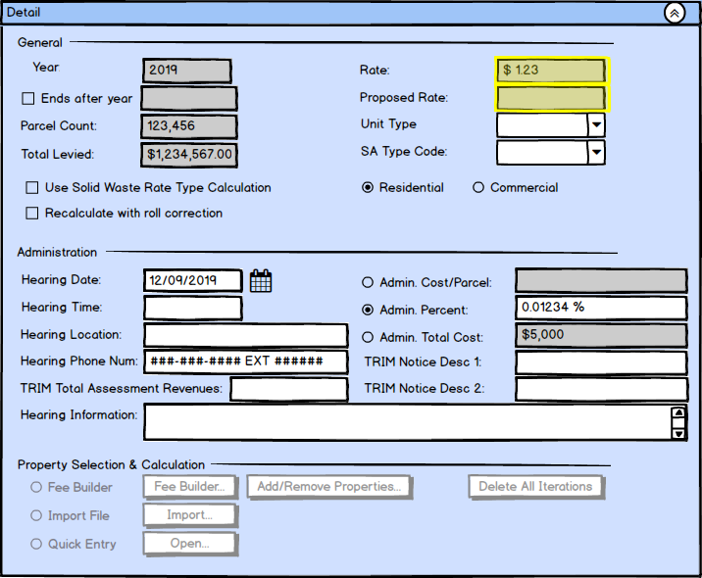

There will be minor changes made to the Proposed Rate and Rate fields.
- Rate
Previously the Rate field is set to the rate value of the first iteration when it is modified by the user .
  - If there is only one Iteration and only one rate on the Edit Fee screen , bi-dimensional change will be allowed
- Hearing Import Rate and Proposed Rate will be copied to Iteration level rate.
- Any manual change of Rate and Proposed Rate on Special Assessment Details dialog will be copied to Iteration level rate. This is an existing behavior.
- If Edit Fee screen Iteration Rate or Proposed Rate is changed , the Rate and Proposed Rate of the iteration will be copied backward over to the Hearing Rate and Proposed Rate respectively on the Special Assessment Details dialog. This is an existing behavior.
  - If there are more than one Iterations:
- Hearing Import Rate and Proposed Rate will not be copied to Iteration level rate.
- Rate and Proposed Rate on Special Assessment Details dialog will be read-only , so no changes can be made manually.
- No rate from Edit Fee screen will be copied backward over to the Hearing Rate on the Special Assessment Details dialog after any changes to Edit Fee screen. The Special Assessment Details Dialog Rate and Proposed Rate will continue showing their original values. (This is a change in current behavior where we were coping the first rate of the first iteration.)

- Proposed Rate
This field needs to behave like Rate. Currently it is always enabled and the values are set by what the user enters in this screen only. This behavior needs to change to mimic the Rate field
- Enabled
      - The Proposed Rate will be disabled by default.
      - The Proposed Rate field will be enabled when the data is entered through Import or Quick Entry.
      - The Proposed Rate will be enabled when the data is entered by the user other than Import or Quick Entry , that is using the Fee Builder and there is only one iteration and one rate.
      - For all other cases it will be disabled.

- Value
      - The value can be set by user through the Special Assessment Hearing Information Import process
      - The value will be set to the iteration proposed rate when there is a single iteration and single proposed rate and the user opens the Fee Builder.
      - If the user modifies the proposed rate manually, and there is a single iteration and single proposed rate we want to also update the proposed rate for that iteration.
      - For multiple iterations or multiple rates , the proposed rate on the Special Assessment Details dialog will not be affected by any Iteration Proposed Rate.

Special Assessment Import Dialog changes
Menu Option: PACS Search Special Assessment Agency Special Assessment Agency Detail Import File Import

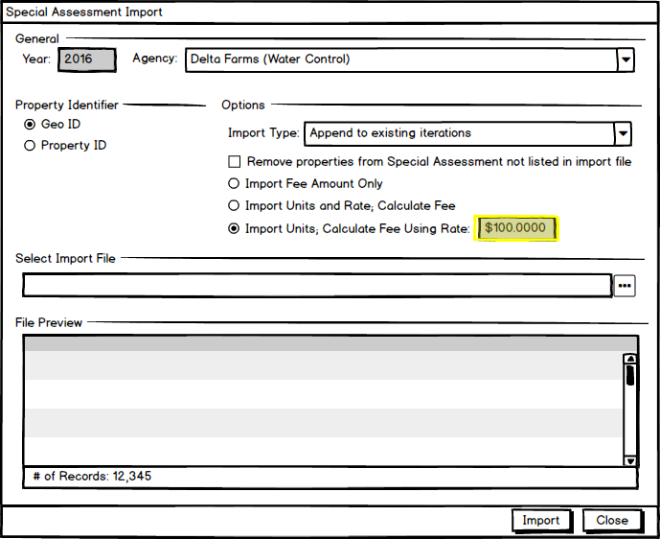

  - Rate
    - The Rate field next to “Import Units, Calculate Fee Using Rate” will always be disabled.
      - The value of this field will be populated from the Rate field on the Special Assessment Details dialog.

Edit Fee Dialog modifications

The Edit Fee dialog will be modified to display and edit the new Proposed Rate.

Menu Option: PACS Search Special Assessment Agency Special Assessment Agency Detail Fee Builder

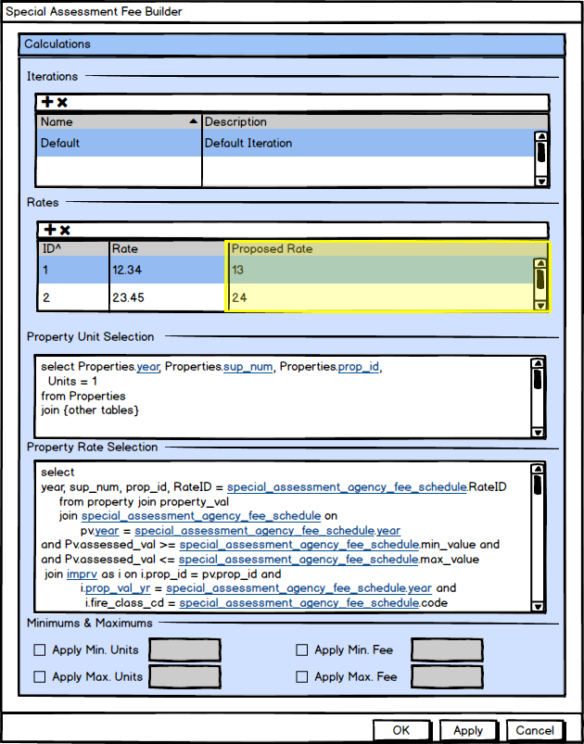

Fig 8-1: Edit Fee Dialog

The following modification will be made to the Edit Fee dialog:
- Proposed Rate – A new column Proposed Rate will be added to the Rates grid.
  - This column will be editable.
  - This will display the Proposed Rate that was imported or entered by the user on this screen for the special assessment iteration.
  - The value of this field will come from and will be saved to [special_assessment_iteration_rate].proposed_rate
  - It is not a required field and will default to 0.0000
  - Allowed values are from -99,999.9999 to 999,999.9999

Special Assessments paragraph modifications

The Special Assessments paragraph on the Property View will be modified to display the new Proposed Rate and Proposed Fee.
Menu Option: Property View Tax Area & Special Assessments Special Assessments

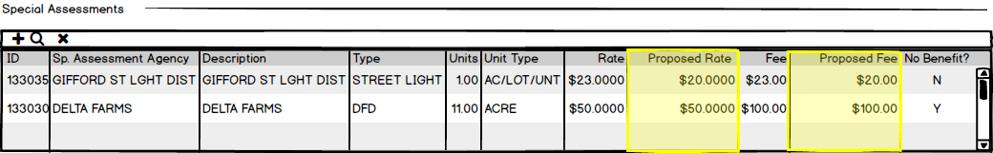
The following modifications will be made to the grid in the Special Assessments paragraph:
- Proposed Rate – A new column Proposed Rate will be added to the grid after the existing Rate column.
  - This column will be read only.
  - This will display the Proposed Rate that was imported or entered by the user for the special assessment iteration or at the property level.
  - The value of this field will come from [property_special_assessment_iteration].proposed_iteration_rate.
- Proposed Fee – A new column Proposed Fee will be added to the grid after existing Fee column.
  - This column will be read only.
  - This will display the Proposed Fee calculated based on the Proposed Rate and Units.
  - The value of this field will come from [property_special_assessment_iteration].proposed_iteration_fee.

Special Assessments Fee dialog modifications

The Special Assessments Fee dialog will be modified to display the new Proposed Rate, an Override Proposed Rate and Proposed Fee fields.

Menu Option: Property View Tax Area & Special Assessments Special Assessments Click on Special Assessment Detail

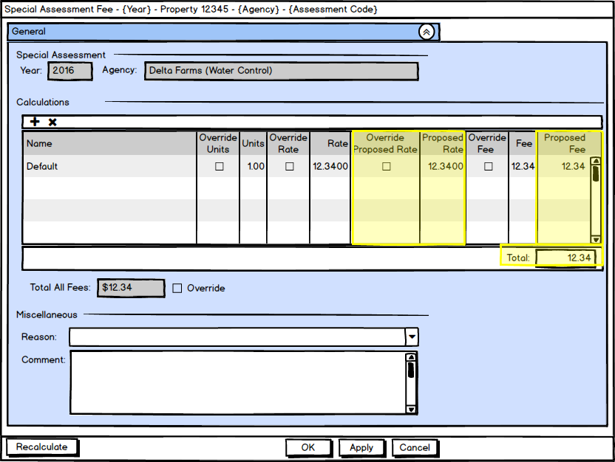

The following modification will be made to the grid in the Calculations paragraph:
- Override Proposed Rate – A new column Override Proposed Rate will be added to the grid after the existing Rate column. This field will allow the user to override the Proposed Rate for the property.
  - This will be an editable checkbox.
  - This will allow the user to override Proposed Rate for the property iteration.
  - The value of this field will come from [property_special_assessment_iteration].proposed_iteration_rate_override.
  - When this field is checked, the new Proposed Rate column will be enabled.
  - When this field is unchecked, the new Proposed Rate column will be disabled.

- Proposed Rate – A new column Proposed Rate will be added to the grid after the new Override Proposed Rate column. The user can edit the Proposed Rate for the property using this field.
  - This field will be enabled when “Override Proposed Rate” column is checked.
  - This field will be disabled when “Override Proposed Rate” column is unchecked.
  - This will display the Proposed Rate at the property iteration level.
  - The value of this field will come from and saved to [property_special_assessment_iteration].proposed_iteration_rate.

- Proposed Fee Amount – A new column Proposed Fee Amount will be added to the grid after existing Fee Amount column.
  - This will be a read only column that will display the Proposed Fee calculated.
  - This will display the Proposed Fee calculated based on the Proposed Rate and Units. (Proposed Rate x Units.)
The value of this field will come from [property_special_assessment_iteration].proposed_iteration_fee.
- Total – Remove the Total.

Recalculation modifications

The Recalculation engine will be modified to do the following:
- Set up the Proposed Rate for the special assessment and property.
- If the Rate selection query has a code , ensure the code is considered when fetching the rate Id for rate calculation.
- Override the proposed rate on the property if it was overridden in the Special Assessment Fee dialog for the property.
- Calculate the proposed Fee and use the maximum Proposed Fee from the iterations to set for the property unless its overridden at the property level.
- Use the maximum Proposed Fee from the iterations to set the Proposed Fee on the main Special Assessment Page.

Report Data modifications
Report Modifications
There will be some modifications to reports where the Special Assessment Rates and Fees are displayed.
The user will be provided an option to choose from Rate or Proposed Rate.
  - If the user chooses “Proposed Rate”, the identified reports will use the proposed rate calculations for the special assessment fee.
  - If the user chooses “Rate”, the identified reports will use the rate calculations for the special assessment fee.

Reports identified for these changes are :
- Tiff Detail Report
Reports CRA/TIF CRA/TIF Property Detail Report

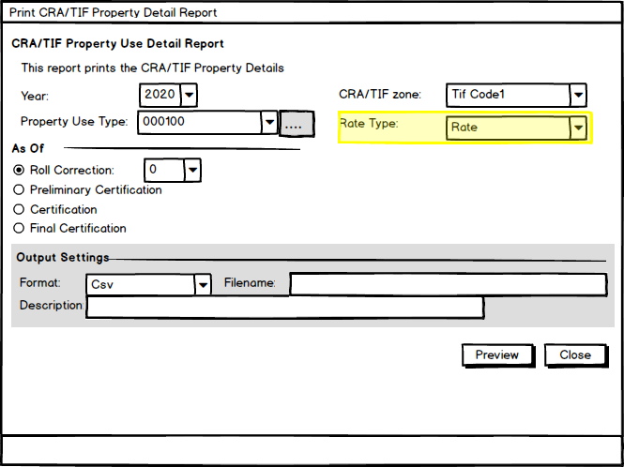

A new field will be added to the CRA/TIF Property Detail Report dialog:
    - Rate Type
        - This will be a new combo box that will allow the user to choose between “Rate” and “Proposed Rate”.
        - By default “Rate” will be selected.

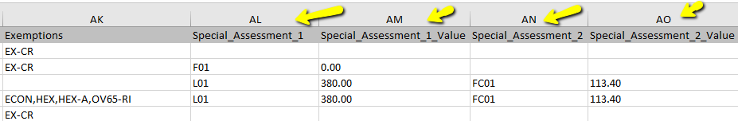

Fields - Special_Assessment_X_Value fields

- If Proposed Rate is chosen, the Proposed Fee calculated using Units x Proposed Rate will be used for the Special Assessment Value .
- If Rate is chosen, special assessment fee calculated using Units x Rate will be used.

- Non-Ad Valorem Assessments

Activities Trim Notice Non-Ad Valorem Assessment Report

Similar to the CRA/TIF Property Detail Report in 12.1 -1 above, a new field will be added to the Non-Ad Valorem Assessment Report dialog:
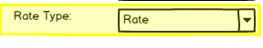
Rate Type
- This will be a new combo box that will allow the user to choose between “Rate” and “Proposed Rate”.
- By default “Rate” will be selected.

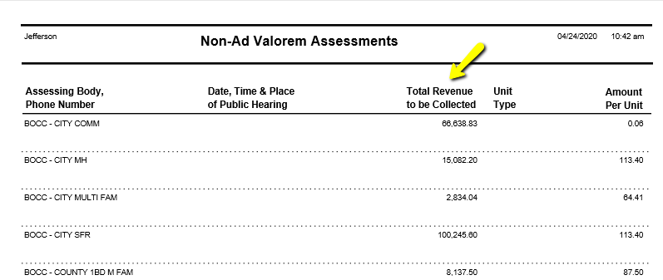

Fields - Total Revenue To Be Collected (sum of the fee)

- If Proposed Rate is chosen, the Proposed Fee calculated using Units x Proposed Rate will be used for adding the fees for “Total Revenue To Be Collected” .
- If Rate is chosen, the special assessment fee will be used.

- Special Assessment Roll Report
Reports Special Assessment Special Assessment Roll Report

Similar to the CRA/TIF Property Detail Report in 12.1 -1 above, a new field will be added to the Special Assessment Roll Report dialog:
Rate Type
- This will be a new combo box that will allow the user to choose between “Rate” and “Proposed Rate”.
- By default “Rate” will be selected.

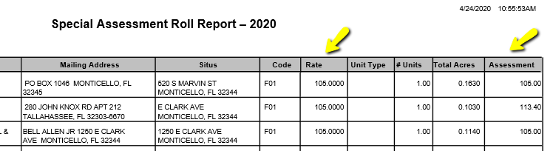
Fields - Rate and Assessment (fees)

- If Proposed Rate is chosen, the Proposed Rate and Proposed Fee calculated using Units x Proposed Rate will be used for Rate and Assessment respectively .
- If Rate is chosen, the Rate and special assessment fee calculated using Units x Rate will be used.

- Special Assessment Summary Report
Reports Special Assessment Special Assessment Summary Report

Similar to the CRA/TIF Property Detail Report in 12.1 -1 above, a new field will be added to the Special Assessment Summary Report dialog:
Rate Type
- This will be a new combo box that will allow the user to choose between “Rate” and “Proposed Rate”.
- By default “Rate” will be selected.

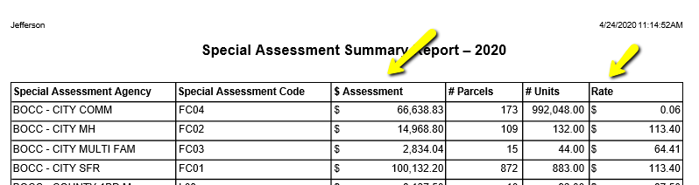
Fields - Assessment and Rate
- If Proposed Rate is chosen , the Proposed Rate and Proposed Fee calculated using Units x Proposed Rate will be used for Rate and Assessment respectively .
- If Rate is chosen, the Rate and special assessment fee calculated using Units x Rate will be used.

- Special Assessment Calculation Comparison Report
Reports Special Assessment Special Assessment Calculation Comparison Report

Similar to the CRA/TIF Property Detail Report in 12.1 -1 above, a new field will be added to the Special Assessment Calculation Comparison Report dialog:
Rate Type
- This will be a new combo box that will allow the user to choose between “Rate” and “Proposed Rate”.
- By default “Rate” will be selected.

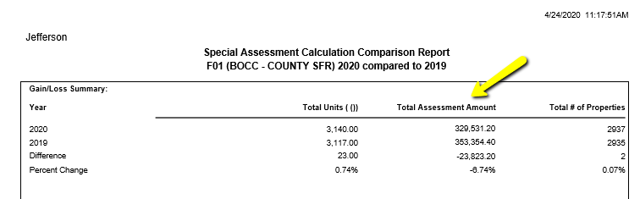
Fields - Total Assessment Amount

- If Proposed Rate is chosen, the Proposed Fee calculated using Units x Proposed Rate will be used for Total Assessment Amount .
- If Rate is chosen, the special assessment fee calculated using Units x Rate will be used.

New Year Layer, Future Year Layer, Roll Correction, Copy Property To Another Year Layer modifications

The Proposed Rate on the special assessment and Proposed Rate, override and proposed fee fields for iteration will be copied over in the case of :
- Property roll correction
- Copy Property to another Year Layer
- Future Year Layer
- New Year Layer

