R50 SP – LID Lift excluding SNR

This release service pack focuses on the legislative change for senior properties to be excluded from the portion of levy increase approved by voters, also known as a ‘lid lift’:

Tax District Details
HLL panel
HLL Calculation
Tax District Levy Calculation Summary Report

**Reports below related to values or levy have not been modified at this time

Assessment and Levies Due
Assessment/Taxroll Reconciliation
Certification of Levies
Certification of Values by Tax Area
Fund Listing
Levy Rate Summary
Levy Rates by Tax Area
Levy Rates Report
List of Tax Areas within Tax District
Listing of Levies within Tax Area
Print Certification of Value Letter Report
Refund Levy Run
Timber Assessed Values Report
Top Taxpayers

2018 Legislation
SHB 2597
(5)(a) A person who otherwise qualifies under this section and has a combined disposable income of forty thousand dollars or less is exempt from all excess property taxes ((and)), the additional state property tax imposed under RCW 84.52.065(2), and the portion of the regular property taxes authorized pursuant to RCW 84.55.050 and approved by the voters, if the legislative authority of the county or city imposing the additional regular property taxes identified this exemption in the ordinance placing the RCW 84.55.050 measure on the ballot;

Tax District Details
Allow clients to indicate that the SNR/DSBL exemption was included on the ballot with the voted levy lid lift. This allows the client user to track whether the snr/dsbl portion should be exempt from calculations.

- Tax District > General > Election Information
  - A new column is added to the election information section on tax district details
  - The new selection can be copied to the levy details consistent with existing functionality
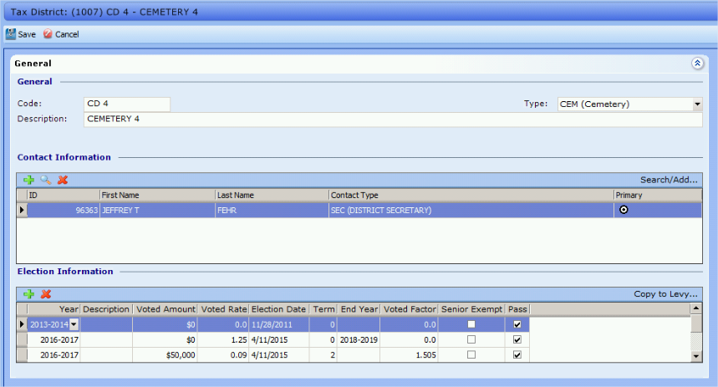

HLL panel

- Levy Certification run > details > Highest Lawful Levy Limit
  - Add a column in the grid to represent the Tax Base for senior properties exempt from the lid lift portion
  - Add a column for the Levy Rate associated to the Senior exempt properties
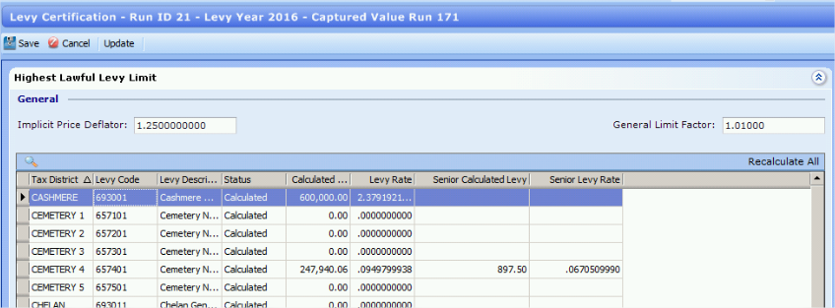

- Highest Lawful Levy Limit > Click details
  - Track and display the taxable value for the Highest Lawful Levy and the Taxable Value for the Lid Lift Levy.
  - Indicate that the snr/dsbl exemptions are not included in the lid lift
  - Update the calculation of voted levy to account for the lid lift excluding senior properties
    - if voted amount is not provided, use the voted rate to calculate the voted amount, excluding senior properties
    - (total taxable value - SNR taxable value) * voted rate / $1,000 = Voted levy
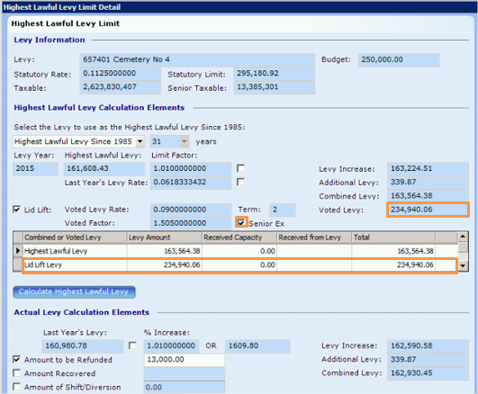
HLL Calculation

- When indicated, exclude the additional taxes assessed using the lid lift rate or levy amount for properties with SNR/DSBL exemption
  - Determine the taxable value of the district as if the lid lift with the exemption had never occurred and the taxable value subject to the lid lift increase. The difference between these two taxable values is the taxable value subject to the district’s levy as if the lid lift had not occurred.
  - The levy calculations will remain the same as far as determining which rate applies. The statutory limit rate comparison remains in effect regardless of the lid lift changes.
  - For the first year of the levy lid lift
    - Follow these four steps:
      - 1. Calculate the levy amount and rate as if the voters did not approve the levy lid lift.
      - 2. Calculate the levy amount based on the rate approved by the voters.
      - 3. Calculate the total levy amount for the levy. This is the levy amount to be collected from property exempt from the lid lift and property subject to the lid lift.
      - 4. Calculate the levy rates to be applied to the property that is exempt from the lid lift and the property that is subject to the lid lift. You will use the greater of these two levy rates when reviewing the $5.90 and Constitutional 1% aggregate levy limits.
    - EXAMPLE
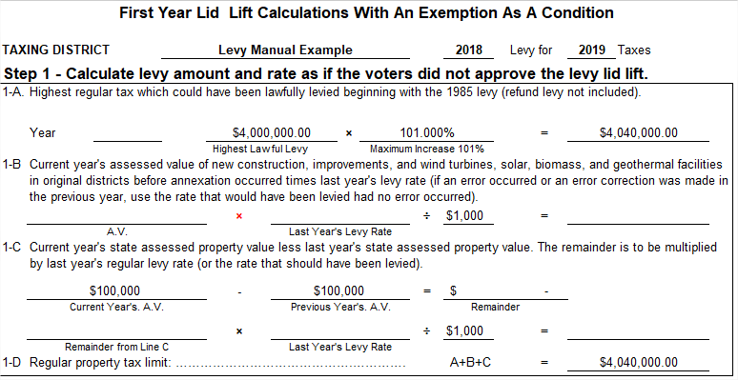
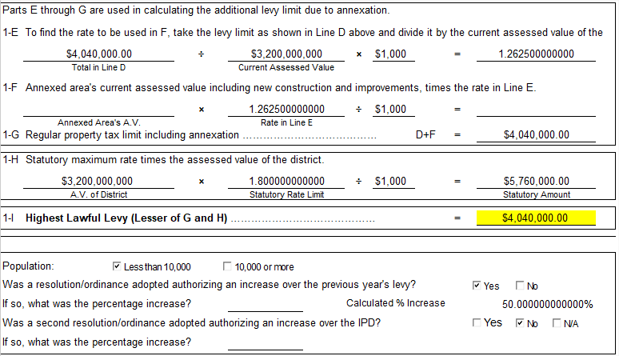
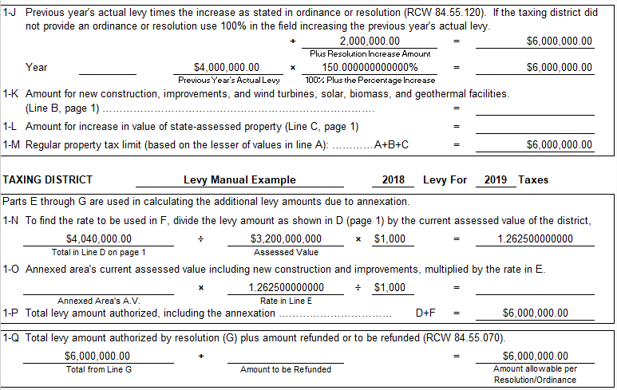
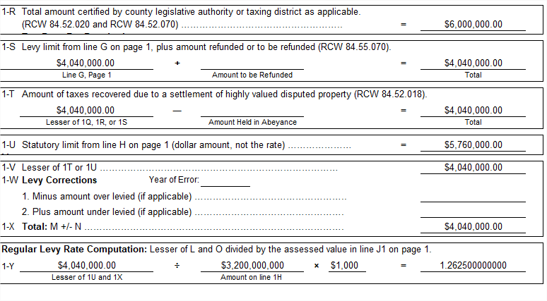
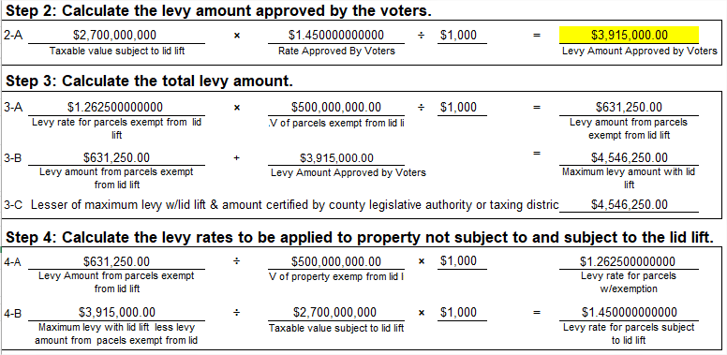
      - Voters approved a single-year levy lid lift setting the levy rate at $1.45 per $1,000 assessed value, with a condition exempting property qualifying for [SNR/DSBL] from the increased levy capacity.
        - Taxable value of the district - $3,200,000,000
        - $500,000,000 of the taxable value qualifies for a [SNR/DSBL] exemption
        - District’s prior year levy and highest lawful levy since 1985 - $4,000,000
        - District’s current year budget request - $6,000,000
        - District passed an ordinance authorizing an increase in their levy, $2,000,000 or 50%
        - District’s population is less than 10,000
        - District’s statutory maximum levy rate $1.80 per $1,000 assessed value
        - There is no new construction or increase in state assessed utility value for this assessment year
      - Step 1:
Complete the levy calculations as if the lid lift had never occurred to determine the levy rate that will apply to property receiving a [SNR/DSBL] exemption:
        - Determine the levy’s levy limit by increasing the highest lawful levy by the 101% limit factor:

$4,000,000 * 101% = $4,040,000
        - Determine the statutory maximum levy amount:

$3,200,000,000 * 1.80/1000 = $5,760,000
        - Determine the levy amount authorized by the district’s ordinance increasing their property tax over the prior year’s property tax:

$4,000,000 + $2,000,000 = $6,000,000
        - Compare the prior three levy amounts to the district’s budget request, $6,000,000, and calculate a levy rate based on the lesser levy amount. This is the levy rate that will be applied to the property exempt from the levy lid lift:

$4,040,000 / $3,200,000,000 * $1,000 = $1.2625 per $1,000 assessed value
      - Step 2:
        - Determine the levy amount approved by the voters using the taxable value subject to the lid lift:

($3,200,000,000 - $500,000,000) * $1.45 / $1,000 = $3,915,000
      - Step 3:
        - Determine the amount of taxes the levy will generate from the property subject to the lid lift and exempt from the lid lift:

$1.2625 * $500,000,000 / $1,000 = $631,250 (this is the amount from property exempt from the lid lift.)
        - Determine the total levy amount

$631,250 + $3,915,000 = $4,546,250
        - Double check this amount does not exceed the district’s budget request. If it does not, the rates determined in this step and step 2 are the rates you will include in the tax roll and apply to the appropriate parcels. If it exceeds the budget request, you must reduce the amount levied against the property that qualifies for the lid lift, see Step 4.
      - Step 4:
        - If the levy amount in Step 3 exceeds the district’s budget request, subtract the levy amount from property exempt from the lid lift from the district’s budget.
          - This is the amount that must be levied against the property subject to the lid lift.
          - Divide the amount to be levied against the property subject to the lid lift by the taxable value of property subject to the lid lift.
          - This will be the levy rate applied to those parcels.
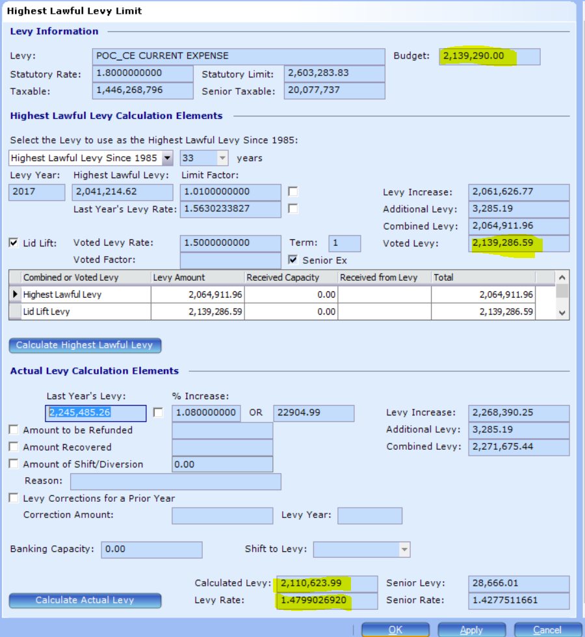
Use the lesser of the max levy with lid lift & the budget in the calculate rates section.
Total calculated levy =
1.4277511661 * 20,077,737/1000 = 28,666.01
+
2,139,290
=
2,167,956.01 (max levy with lid lift)
Calculate rates =
28,666.01/20,077,737*1000 = 1.4277511661

(2,139,290 - 28,666.01)/1,426,191,059*1000 =
1.47990269
  - The year following the first year of the lid lift, and all subsequent years, continue to calculate the levy limitations as if the voters had never approved the lid lift until the lid lift expires.
    - You can accomplish this by either using Step 1 on the First Year Lid Lift Calculations with an Exemption worksheet or the regular levy limit worksheet. This is considered the HLL in PACS.
    - Once again, this is the levy rate you will apply to property that does not have the [SNR/DSBL exemption where the lid lift is in effect].
  - When determining the highest lawful levy for the portion of the district’s levy subject to the lid lift for the year following the lid lift and all subsequent years until the lid lift expires, you will carry forward the levy amount the voters authorized, levy rate multiplied by the taxable value of the district subject to the lid lift, $6,500,000 using our example.
    - Increase that levy amount by the appropriate limit factor [for the district] or the limit factor/specified index stated in the ballot title if the lid lift is a multi-year lid lift.
    - You will use the actual levy rate applied to the property subject to the lid lift from the prior year to increase the current year’s, new construction, improvements to property, newly constructed wind turbines, and increases in state-assessed property.

Tax District Levy Calculation Summary Report

- Tax District Summary panel > select tax district > Print
  - update calculations – existing row where seniors are exempt for lid lift will not include senior properties
  - add a row for the senior base and rate to the lid lift section to populate when seniors are exempt from lid lift
